Topic: Measurement | EQ: Where do we use measurement in the real world?
Questions  How do we measure?  What if the scale doesn’t start at 0? | Notes:  When measuring something have to make sure we go from one end to the other, it doesn’t matter if it is sideways (horizontal) or up and down (vertical).  It is also import to know which units we are using. 1m is much shorter than 1km.  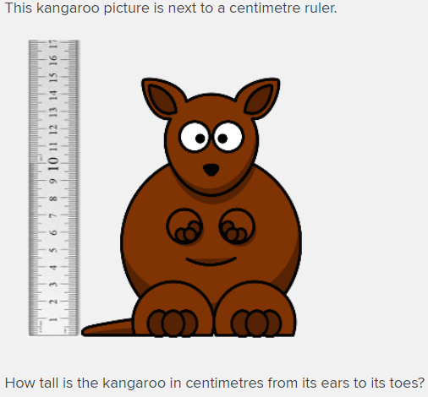  Look at the scale on the ruler. Notice the kangaroos feet are at 0cm. What number is closest to the top of the kangaroo’s ears?  Answer: 15cm  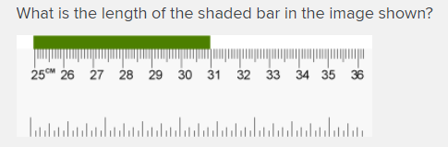  Notice that the green bar doesn’t start at 0cm, it starts at 25cm and finishes at 31cm.  We can write this as 31 – 25 centimetres.  Subtract 25 from 31 to get the answer  Answer: 6cm

WORKSHEET
